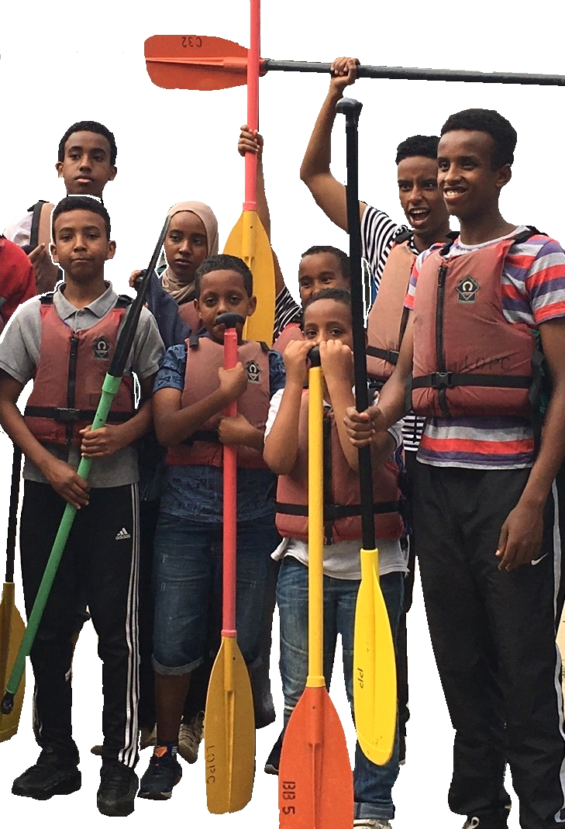
Leicester Young Ecology Adventurers
PROGRAMME SAFETY REVIEW
Version 1.0
June 2017

1. INTRODUCTION
This document outlines the key issues that SOCOPA and its partners need to consider in order to make sure that risk is managed effectively in the Leicester Young Ecology Adventurers (LYEA) programme.
Each organisation involved in the programme (SOCOPA, Canal and River Trust, Leicester Outdoor Pursuits Centre and Cardiff University) all have their own safety procedures and plans in place. This document is not intended to replace these, but to demonstrate that SOCOPA itself is taking a leadership role in this area and is actively managing the risks that exist in outdoor education activities of this kind.
SOCOPA is the beneficiary of Heritage Lottery Funds which have been provided on the basis that young people will benefit from taking part in a safe and enjoyable programme. CRT has generously offered in kind support and access to its volunteers for the programme; LOPC, Cardiff University and JonBoageyLtd are directly sub-contracted to deliver the programme and it is SOCOPA’s responsibility to actively make sure that these partners are clear about their roles and are confident in SOCOPA’s management responsibility.
SOCOPA has used a number of reference documents in creating this Programme Safety Review including:
- NSPCC’s Online self-assessment tool for organisations working with children and young people
- Canal and River Trust Safeguarding Children Young People and Adults at Risk Mandatory Standard
- Leicester Outdoor Pursuits Safeguarding People Policy 2010 (Reviewed 2017)

2. PROGRAMME DESCRIPTION

LYEA is a new programme for 11-14 year olds living in Leicester. It aims to broaden young people’s knowledge and experience of the natural environment, build their personal and social skills and experience the outdoors, particularly through canoeing. Participants completing the 12 week programme will be awarded the John Muir Award.
The first, pilot programme will run from 5th July to mid-September 2017 with a final date for a ‘graduation’ celebration to be confirmed in October 2017. Once the 2017 programme has been evaluated two further programmes will be delivered in 2018. 22 young people have enrolled on the 2017 pilot programme.
SOCOPA’s role, working with partners, is to create and deliver the programme, ensuring young people are recruited, the activities are well organised and safely delivered according to detailed activity plans which are created from the main plan in Annexe 1.
The Canal and River Trust has provided advice and support in the programme design and will support a number of the work sessions by providing or facilitating volunteers (e.g. lockkeepers, ecologists and bat experts).
Leicester Outdoor Pursuits Centre will provide qualified staff while the young people are on the water in canoes as well as learning/ debriefing room before and after the water activity.
Cardiff University will evaluate the programme and attend a number of sessions to interview participants in focus groups.
Young people join the programme with the permission of their parents or guardian. Most activities take place in the early evening from 5.30 – 8.30 with a couple of exceptions: a 6am start to recover camera traps set in the evening session earlier in the week; and a later activity from 7-10pm to record bats in the Saddington Tunnel. These activities are intended to provide an element of excitement and to create memorable experiences for the young people as well as provide observation of the waterway ecology.

3. PRIORITISING YOUNG PEOPLE’S SAFETY; ASSESSING THE RISK

The sections below are informed by the NSPCC’s On-line self-assessment tool for organisations working with young people. The LYEA programme is voluntary – young people attend with the agreement of their parent/s guardian/s and SOCOPA is entrusted, in loco parentis, to provide a safe and enjoyable experience for the young people.
The key elements of SOCOPA’s risk assessment include:
- Ensuring clear leadership for the programme and clarity about responsibilities and decision making concerning risk management;
- balancing the risk involved in outdoor activities, particularly canoeing, against the benefits to young people of new skills and experiences;
- making sure safeguarding policies and procedures for young people are in place and all staff and volunteers understand them and know what to do if an issue relating to child protection arises;
- travel arrangements ensure all young people can participate in the programme and return home safely;
- practical rules are in place to safeguard children’s identity. This includes personal information as well as use of photographic images taken during activities for example on social media or in presentations and press releases.

3.1. ENSURING CLEAR LEADERSHIP AND SUPERVISION IN THE PROGRAMME

3.1.1 Effective outdoor education programmes that achieve learning outcomes and ensure young people have a safe and enjoyable experience are dependent on good programme leadership.
3.1.2 The LYEA is led by SOCOPA and its chief executive, Abdikayf Farah. He is supported in the programme design and management by Jon Boagey, a youth programmes consultant. The programme design and detailed arrangements for each week’s activity have been discussed and agreed at programme steering group meetings at which the partners have been present (see Annexe 1). The programme learning outcomes are also clearly set out in the work plan.
3.1.3 Abdikayf Farah, consulting with colleagues, is responsible for making decisions about the balance of risk in the programme, ensuring the staff /child ratios is sufficient and all other decisions about the safety and protection of children in the programme are maintained. Much of the higher risk activity will take place in and around the waterway at the Leicester Outdoor Pursuits Centre and responsibility for safety in the canoes will be delegated to the canoe instructors.
3.1.4 There are no statutory requirements relating to staff/ child ratios and different organisations make different recommendations. NSPCC suggests for 9-12 year olds the ratio should be 1:8 and for 13-18 year olds this can be 1:10. It seems reasonable that SOCOPA, given the age range of 11-14 ensure a minimum ration of 1:9. Because we expect 22 participants on the first programme we should aim to have at least 3 adults with young people at all times. This will provide a ratio of under 1:8.
3.1.5 Abdikayf Farah will be the principal supervisor with overall responsibility for decision making while the programme sessions take place. In the event that he cannot attend, he will delegate this responsibility to [xxx].
3.1.6 Abdikayf is also the principal contact for parents and maintains the register of participants.
ENSURING CLEAR LEADERSHIP FOR THE PROGRAMME
Risk description | Risk Impact | Likeli-hood | Mitigation Action Undertaken | Retained risk
Lack of active leadership responsibility and clear lines of accountability / delegation between partners and staff/ volunteers involved in the programme. | H | M | SOCOPA ensures contracts/ legal agreements are in place for partners. Partners understand role of SOCOPA CEO as overall responsibility for programme and when supervisory/ activity responsibilities are delegated.  Weekly session plans identify named overall responsible staff member, other staff and volunteers contributing and any delegated responsibilities for individual segments for that session (e.g. transport to/ from venue/ briefing sessions/ canoeing). | M
Lack of active supervision of children and lack of clarity about this role between SOCOPA and partner organisations. | H | M | Session plans will identify session lead staff and those responsible for segments. There will always be adequate support for those leading segments and SOCOPA CEO will be responsible for ensuring participants are well behaved, their needs are supported and their safety is maintained.  SOCOPA CEO will be responsible for ensuring adequate staff/ participant ratios are maintained throughout the programme. This ration will vary depending on risk and nature of activities. | M
Lack of clarity about achievement of overall learning goals/ outcomes in the programme and how these will be achieved/ who is responsible for achieving them. | M | . M | This will be set out in the Programme Workplan as well as the Weekly session plans | M
Inadequate arrangements for registering participants each week. | H | .L | Arrangements for dropping off and picking up children will be explained at the programme induction day on 5th July. A full register of participants will be maintained, including parental permissions, contact details etc.  A written registration will take place upon boarding transport to the venue, at the start of the first segment and on departure from the venue. | L
Inadequate arrangements for registering permissions and securing personal details for children. | H | .L | All personal details and permissions will be registered at the induction event for parents and children on 5th July | L

3.2 BALANCING RISK IN OUTDOOR ACTIVITIES
“HSE fully recognises that learning outside the classroom helps to bring the curriculum to life – it provides deeper subject learning and increases self-confidence. It also helps pupils develop their risk awareness and prepares them for their future working lives. Striking the right balance between protecting pupils from risk and allowing them to learn from school trips has been a challenge for
many schools, but getting this balance right is essential for realising all these benefits in practice”.

(School trips and outdoor learning activities: Tackling the health and safety myths, HSE, 2014)

3.2.1 SOCOPA believes that by working with the right partner organisations it is able to mitigate the risks to young participants in delivering outdoor education activities. Outdoor Activities will take place at the LOPC which is licensed by the Adventure Activities Licensing Authority and accredited and recognised by a range of other bodies including British Canoeing, Council for Learning Outside the Classroom, Adventure Activity Industry Advisory Committee and the Institute for Outdoor Learning. By working with these partners (including those recommended by CRT to provide boats for bat recording) we will ensure procedures such as site specific risk assessment, equipment checks, designated first aiders, first aid arrangements
3.2.2 The programme has been designed to include an exploration of the waterway ecology using canoes as the main form of travel. Other waterside activities include lock keeping, water analysis and a trip on boats to observe bats in Saddington Tunnel. Our assessment is that the risks are well managed and proportionate to the benefits that will accrue to young people. It is important that the young people feel a sense of challenge in the programme and this will be achieved by an early morning canoe to pick up camera traps, and an evening boat trip to monitor bats. Both of these activities will be full supervised by professional and licenses staff.
3.2.3 SOCOPA will maintain an accident register and incident recording book for the programme. This will be in addition to any records made by LOPC.
3.2.4 Individual session activity plans will identify specific risks. Overall we have identified the following in relation to water-based activities:

BALANCING RISK IN OUTDOOR ACTVITIES
Risk description | Risk Impact | Likeli-hood | Mitigation Action Undertaken | Retained risk
Children take part in canoeing activity without familiarisation or proper safety instructions or equipment (e.g. life jackets). | H | L | All children will be required to attend canoe training and safety familiarisation in Week 1. This will be a requirement for progression onto the rest of the programme. | L
Children are not supervised by trained canoeing professionals. | H | L | It is a requirement in the agreement between LOPC and SOCOPA that 1 trained member of staff works with 8 young people. We will have 3 trained staff for 3 groups. | L
Children capsize or fall in the water who cannot swim. | M | M | Children will be taught safety procedures in Week 1 and this will include learning to capsize. This will be explained to parents on the induction day. | M
Children are injured or fall into the water during lock training. | H | L | SOCOPA and other staff will be responsible for supervising children at all times during lock training. Life jackets will be worn by the children at all times and the briefing by the lock keeper will include safety information. | L
Children fall into the water during river dipping. | M | L | A suitable location will be found where the reach to the water is not too high. Children will all wear life jackets during this activity. | L
Children fall overboard on boat trip to Saddington Tunnel. | H | L | All children will be given a safety briefing before the boat starts and will wear life jackets. They will be supervised at all times by SOCOPA staff. | L
Children are injured moving canoes in and out of the storage areas. | M | L | Risks will be explained to children during the canoe training in week one. | L

3.3 SAFEGUARDING POLICIES AND PROCEDURES
Safeguarding
3.3.1 SOCOPA takes safeguarding very seriously. All its staff have undertaken training through Leicester City Council and SOCOPA itself is a registered organisation for processing of DBS checks. All staff engaged by SOCOPA have been DBS checked, including Jon Boagey as a consultant (Enhanced DBS).
3.3.2 SOCOPA’s Chief Executive (or deignated deputy) will be the principal safeguarding lead for the programme as part of his leadership role of the programme. In this role he will ensure:
- each organisation participating in the programme has robust and up-to-date safeguarding policies and procedures relating to its staff and volunteer recruitment;
- that all staff and volunteers participating in the programme have undertaken and can confirm that they have undertaken suitable safeguarding training and understand the practical application of this training for their participation in the prgoramme;
- that there are clear arrangements for the reporting of incidents in the programme and staff know who to approach if they wish to raise concerns.
- suitable recording systems are in place for documenting any issues that are reported and onward referral processes are clear.
3.3.3 SOCOPA also has policies and procedures relating to bullying and equality and is committed to upholding principles of fair and equal access to the services it provides.
3.3.4 SOCOPA maintains adequate insurance to cover this programme through Zurich Insurance Services (Annexe 3).
SOCOPA has identified the following risks relating to safeguarding in the programme:
SAFEGUARDING POLICIES AND PROCEDURES
Risk description | Risk Impact | Likeli-hood | Mitigation Action Undertaken | Retained risk
A safeguarding incident occurs during the programme. | H | L | SOCOPA and partners have procedures in place; there is a designated safeguarding lead in the programme; all staff are trained and DBS checked and understand the procedures to follow in the event of an incident arising. | L
SOCOPA’s safeguarding procedures are inadequate in effectively managing a safeguarding incident. | H | L | SOCOPA staff are trained in safeguarding and the CEO is designated as safeguarding lead for the programme and understands the procedures to follow, including with Leicester Children’s Safeguarding Board. | L
SOCOPA or one of its partner organisations does not carry out effective DBS checks on a staff member or volunteer. | H | L | DBS checks are required for all staff participating in the programme and assessments are made by partners about whether this is necessary amongst volunteers. | L
Staff and volunteers are not trained properly and fail to report or record a safeguarding incident. | H | L | All staff and volunteers on the programme will be given or will have undertaken safeguarding training. | M
Incidents of bullying arise in the programme; young people feel they do not want to attend because of the behaviour of others. | H | L | Ground rules about bullying will be included in induction and sanctions made clear if this happens; SOCOPA CEO will be responsible for responding to allegations in fair and open way. | L

3.4 Safe travel arrangements
3.4.1 SOCOPA recognises that is acting in loco parentis while the children are participating in the programme and it recognises this responsibility and the need to maintain robust arrangements for children’s safety. It is essential that arrangements are clear for their arrival at the rendezvous point and for returning home at the end.
3.4.2 SOCOPA will ensure that all relevant parental permissions are given and any specific instructions are noted in the register. Any variations in the agreement for returning home will be checked with parents before children are released.
3.4.3 SOCOPA will seek prior confirmation from minibus drivers that their insurance documents and other legal requirements such as road tax, are up-to-date and that they are licensed to drive the relevant vehicles.
3.4.4 At least one member of SOCOPA’s staff, in addition to the minibus driver, will accompany children to and from the venue and hold a copy of the register including arrangements for dropping off children.
3.4.5 Where private arrangements are made to drop off and collect children, these will be notified to SOCOPA in advance and the travel arrangements recorded in the register.
SAFE TRAVEL ARRANGEMENTS
Risk description | Risk Impact | Likeli-hood | Mitigation Action Undertaken | Retained risk
A serious accident occurs while travelling to or from the venue. | H | L | SOCOPA will confirm that drivers are authorised and permitted to drive a minibus for up to 16 passengers; seat belts are installed and worn; insurance is up-to-date. SOCOPA staff accompanying children have parental contact details of all children in the register and carry a mobile phone. | L
A minor accident occurs while travelling to or from the venue. | M | L | SOCOPA will confirm that drivers are authorised and permitted to drive a minibus for up to 16 passengers; seat belts are installed and worn; insurance is up-to-date. SOCOPA staff accompanying children have parental contact details of all children in the register and carry a mobile phone. | L
Children travel to the venue but are not included on the register before they travel. | L | M | All children travelling to and from the venue will be confirmed on the register before travel is permitted. | L
A substitute driver is used that does not have adequate insurance/ licenses. | M | M | SOCOPA will not allow children to travel is the driver cannot demonstrate they are legally allowed to drive the vehicle and all the necessary licenses and insurance is in place. | L
There are not enough vehicles to carry the children to the venue. | L | M/H | Arrangements to do two trips or pay for commercial taxi, accompanied by a SOCOPA member of staff will be used. | L
Children cannot attend on time, are late and travel is delayed. | L | H | Every effort will be made to leave at the agreed time, so that the activities can take place as planned. If children do not arrive on time a phone call will be made to the parents and arrangements made for them to return home. | M

3.5 Use of photography and social media
Thanks to LOPC for use of this guidance
3.5.1 The LYEA programme involves communicating to stakeholders and others about the natural environment of Leicester’s waterways. This is a commitment to HLF as the funder and is an integral part of achieving the John Muir Award. Taking photographs, videos and using social media is an important part of this.
3.5.2 SOCOPA wants to make sure that photography of programme activities is of an appropriate nature and any use of images of young people is agreed by the young people themselves and the parents. Parental consent for the use of photographs taken by staff and volunteers on the programme is obtained on the induction day.
3.5.3 It is important to recognise that photographic images may be taken and used in several different ways:
- Photos taken by staff and volunteers for the purposes of communicating about the programme;
- Photos taken by young people themselves are shared on mobile phones and on social media.
- Photos taken by the general public or others attending the LOPC.
SOCOPA is able to manage the first, advise young people on the second but has little influence over the third.
3.5.4 Photos taken by staff and volunteers should be taken to ensure that the possible risks have been reduced. These can include:
- Avoid using the person’s full name with a photograph. This reduces the risk of inappropriate or unsolicited attention.
- Ask the person’s permission and that of the parent or carer if the image is to beused in promotional material.
- Only use images of people in suitable dress. Care should be taken to concentrate on the activity rather than the individual, and should avoid full face or body shots.
3.5.5 SOCOPA will comply with the recommendations in Leicester Outdoor Pursuit Centre’s Safeguarding People Policy:
LOPC request that any person wishing to engage in any video, zoom or close range photography should consider registering their details with staff before proceeding. The organiser reserves the right to refuse any such photography or filming if there are concerns or complaints about its appropriateness, and decline entry to the activity or event to any person unable to meet or abide by the promoter’s conditions.
3.5.6 SOCOPA will include guidelines for young people on taking photographs and posting on social media during the Induction session.
PHOTOGRAPHY
Risk description | Risk Impact | Likeli-hood | Mitigation Action Undertaken | Retained risk
SOCOPA uses photo or video images that are not agreed by parents or young people. | M | L | SOCOPA will seek permission to use video/photographs from parents at the start of the programme. Young people featured in the images will be informed and given the right to decline use. | L
Young people take photographs or video that is inappropriate or not authorised by children/ parents and post these on social media. | M | H | Young people will be briefed about this at the induction. Any inappropriate posting of material on line will be covered as part of SOCOPA’s commitment to safeguarding. | M
A third party takes photographs of participants on the programme during trips to LOPC or another venue. | M/H | L | SOCOPA staff will refer the incident to LOPC under its safeguarding policy; if an incident occurs outside LOPC then SOCOPA’s CEO will raise this issue with the individual concerned and with LCSB and the Police if necessary. | L

Including research ethics

